Max value is 4983

Min value is 31

This is a right side outliers

Variance

Stander deviation is 997.4486

Mean is 1190.316

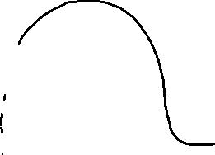

* **Skewness** : I have many right-side outliers , so my distribution is likely positively skewed, this means the tail on the right side of the left side
* **Center Tendency** : the mean will be higher than media in a right-skewed distribution because the high values of the outliers pull the mean towards the right
* **In above chart** : mean is 1190.316 , median is 844 , ST is 997.4484 , Q1 is 414 , Q3 is 1744 , IQR is 1330 and lower limit is -1538 and upper limit is 3739

**So , that’s why in my chart I have many right-side outliers because mean is bigger than median.**